Results for Radon tool on selected projects

Cloning 10 projects:

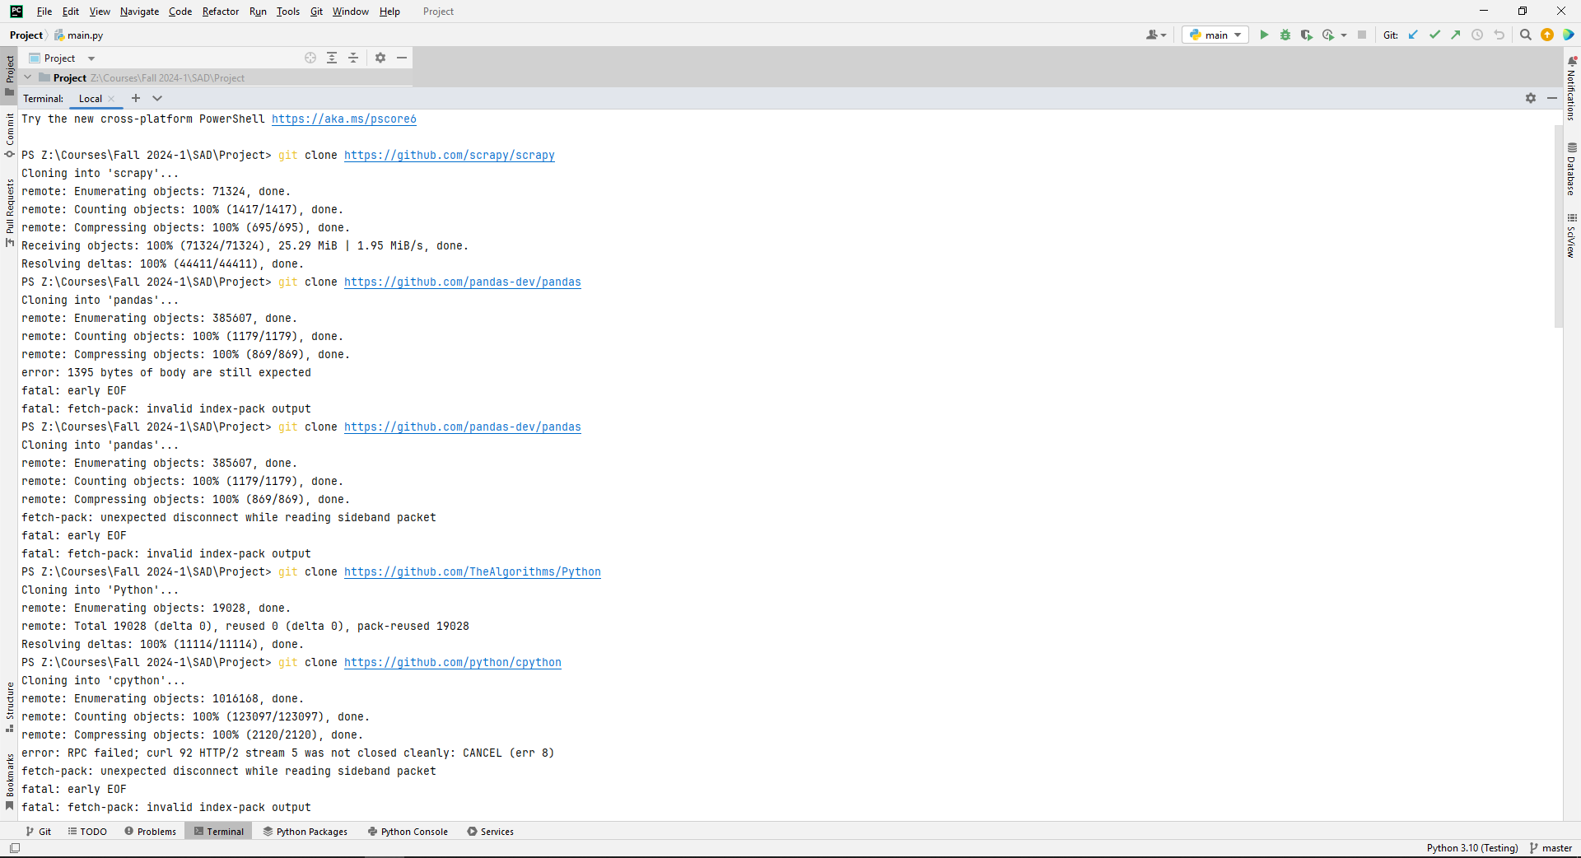

Cloned Projects:

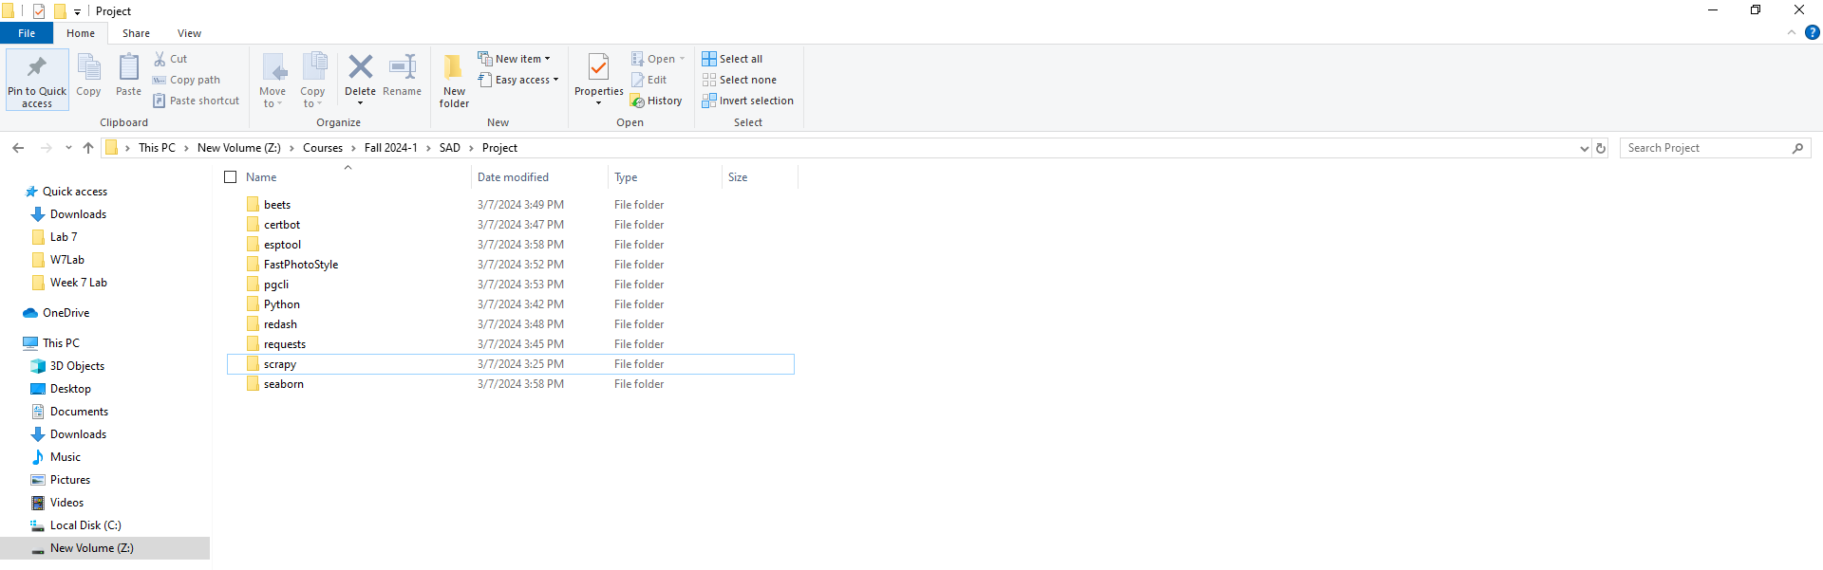

Radon raw –s beets

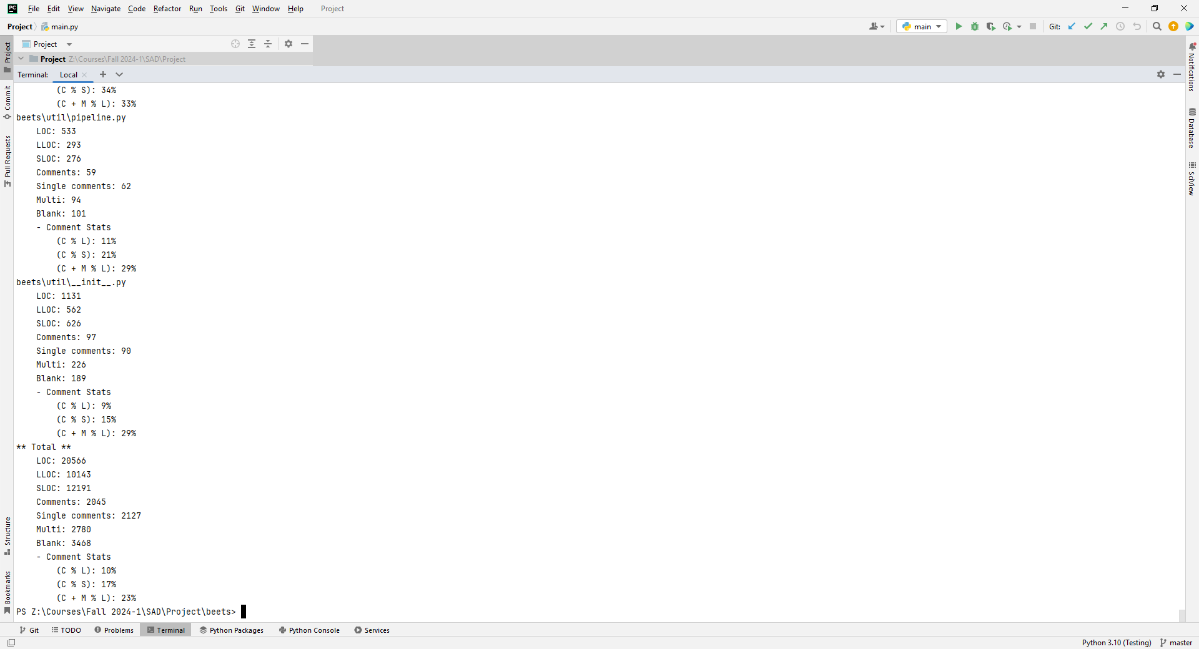

\*\* Total \*\*

LOC: 20566

LLOC: 10143

SLOC: 12191

Comments: 2045

Single comments: 2127

Multi: 2780

Blank: 3468

- Comment Stats

(C % L): 10%

(C % S): 17%

(C + M % L): 23%

Radon raw –s certbot

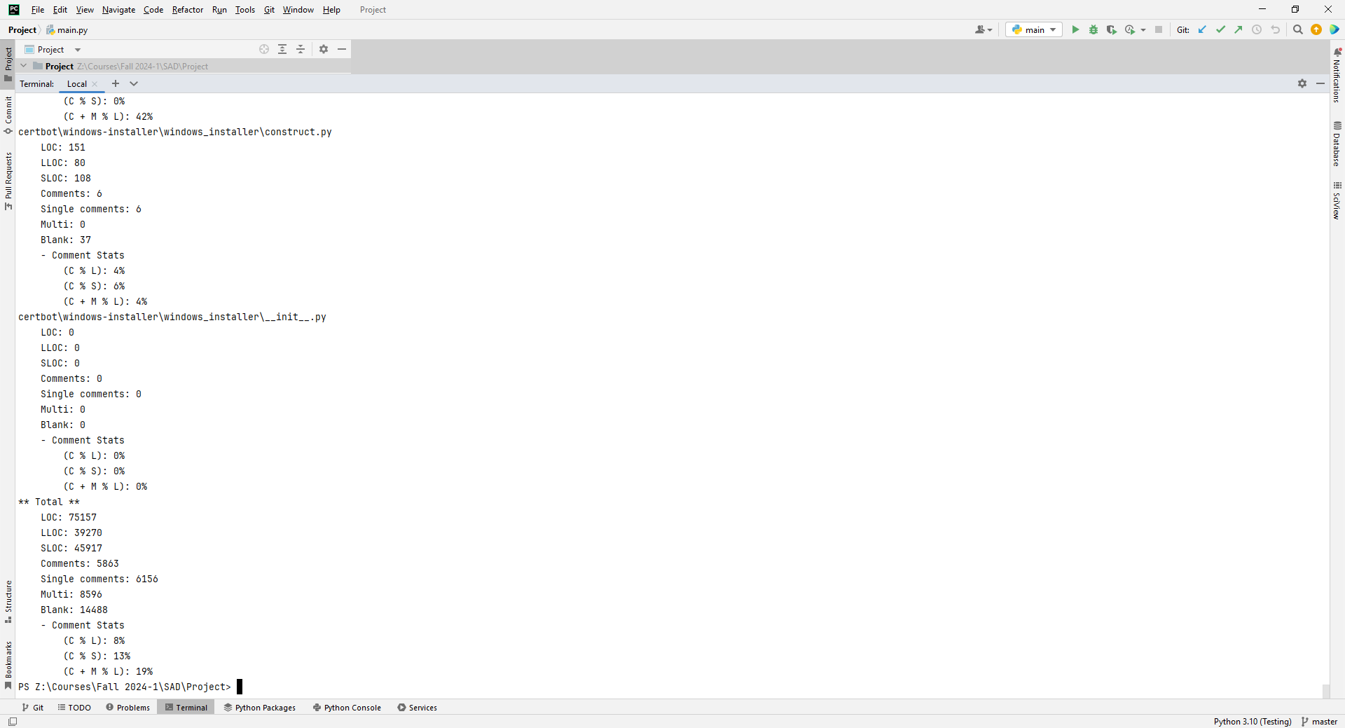

Similarly it applied on all 10 projects. Results are here.

Radon raw –s beets

\*\* Total \*\*

LOC: 20566

LLOC: 10143

SLOC: 12191

Comments: 2045

Single comments: 2127

Multi: 2780

Blank: 3468

- Comment Stats

(C % L): 10%

(C % S): 17%

(C + M % L): 23%

Radon raw –s certbot

\*\* Total \*\*

LOC: 75157

LLOC: 39270

SLOC: 45917

Comments: 5863

Single comments: 6156

Multi: 8596

Blank: 14488

- Comment Stats

(C % L): 8%

(C % S): 13%

(C + M % L): 19%

Radon raw –s esptool

\*\* Total \*\*

LOC: 33379

LLOC: 17922

SLOC: 25993

Comments: 2594

Single comments: 2192

Multi: 699

Blank: 4495

- Comment Stats

(C % L): 8%

(C % S): 10%

(C + M % L): 10%

Radon raw –s FastPhotoStyle

\*\* Total \*\*

LOC: 1787

LLOC: 1061

SLOC: 1384

Comments: 77

Single comments: 72

Multi: 50

Blank: 281

- Comment Stats

(C % L): 4%

(C % S): 6%

(C + M % L): 7%

Radon raw –s pgcli

\*\* Total \*\*

LOC: 13911

LLOC: 6576

SLOC: 10376

Comments: 596

Single comments: 605

Multi: 565

Blank: 2365

- Comment Stats

(C % L): 4%

(C % S): 6%

(C + M % L): 8%

Radon raw –s Python

\*\* Total \*\*

LOC: 110661

LLOC: 42189

SLOC: 44400

Comments: 4536

Single comments: 3901

Multi: 42997

Blank: 19363

- Comment Stats

(C % L): 4%

(C % S): 10%

(C + M % L): 43%

Radon raw –s redash

\*\* Total \*\*

LOC: 40561

LLOC: 22458

SLOC: 30996

Comments: 808

Single comments: 740

Multi: 839

Blank: 7986

- Comment Stats

(C % L): 2%

(C % S): 3%

(C + M % L): 4%

Radon raw –s requests

\*\* Total \*\*

LOC: 10800

LLOC: 5354

SLOC: 6839

Comments: 868

Single comments: 858

Multi: 1106

Blank: 1997

- Comment Stats

(C % L): 8%

(C % S): 13%

(C + M % L): 18%

Radon raw –s scrapy

\*\* Total \*\*

LOC: 63738

LLOC: 35891

SLOC: 48581

Comments: 1931

Single comments: 1670

Multi: 2996

Blank: 10491

- Comment Stats

(C % L): 3%

(C % S): 4%

(C + M % L): 8%

Radon raw –s seaborn

\*\* Total \*\*

LOC: 54875

LLOC: 29448

SLOC: 37334

Comments: 2440

Single comments: 2513

Multi: 3408

Blank: 11620

- Comment Stats

(C % L): 4%

(C % S): 7%

(C + M % L): 11%